Technology Architecture

|  |  |
| --- | --- |
| Date | 27 October 2022 |
| Team ID | PNT2022TMID54166 |
| Project Name | University Admit Eligibility Predictor |
| Maximum Marks | 4 Marks |

Technical Architecture Diagram:

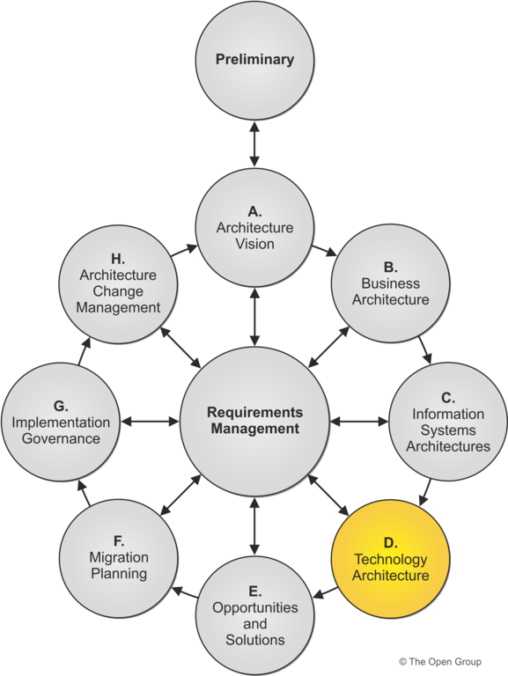

Table-1: Components &Technologies:

|  |  |  |  |
| --- | --- | --- | --- |
| **S. No** | **Component** | **Description** | **Technology** |
| 1 | User Interface | The Front-end part of the application | HTML, CSS |
| 2 | Application Logic-1 | Logic for a process in the application | Python |
| 3 | Application Logic-2 | Logic for a process in the application | IBM Watson |
| 4 | Application Logic-3 | Logic for a process in the application | IBM Watson |
| 5 | Database | Data type, Configuration | MySQL |
| 6 | Cloud Database | Database services on cloud | IBM DB2, IBM Cloudant, etc. |
| 7 | Libraries | Import Libraries into data | Numpy, Pandas, Seaborn, Matplotlib |
| 8 | File Storage | File storage requirements | Local File System |
| 9 | Machine Learning Model | Purpose of Machine Learning Model | Admission Prediction Model |
| 10 | Training and testing data | Purpose of training and testing data | Logistic Regression algorithm |
| 11 | Accuracy | Accuracy of the tested and trained data | Root Mean Squared Logarithmic Error(RMSLE),Mean Squared Error(MSE) |
| 12 | Infrastructure | Cloud Local Server Configuration | Local |

Table-2: Application Characteristics:

|  |  |  |  |
| --- | --- | --- | --- |
| **S.No** | **Characteristics** | **Description** | **Technologies Used** |
| 1 | Open-Source Frameworks | List the open-source frameworks used | Flask Framework |
| 2 | Security Implementations | The user profile has been stored in a secured way | Encryptions |
| 3 | Scalable Architecture | Many computations can be done in a time saving and effective way | Logistic Regression |
| 4 | Availability | Our web application is available at anytime and at any place | IBM Load Balancer |
| 5 | Performance | As logistic regression is applied to develop the performance will be more effective | Logistic Regression |